NEXTAG COMPANY

**Small Saffiano leather wallet**

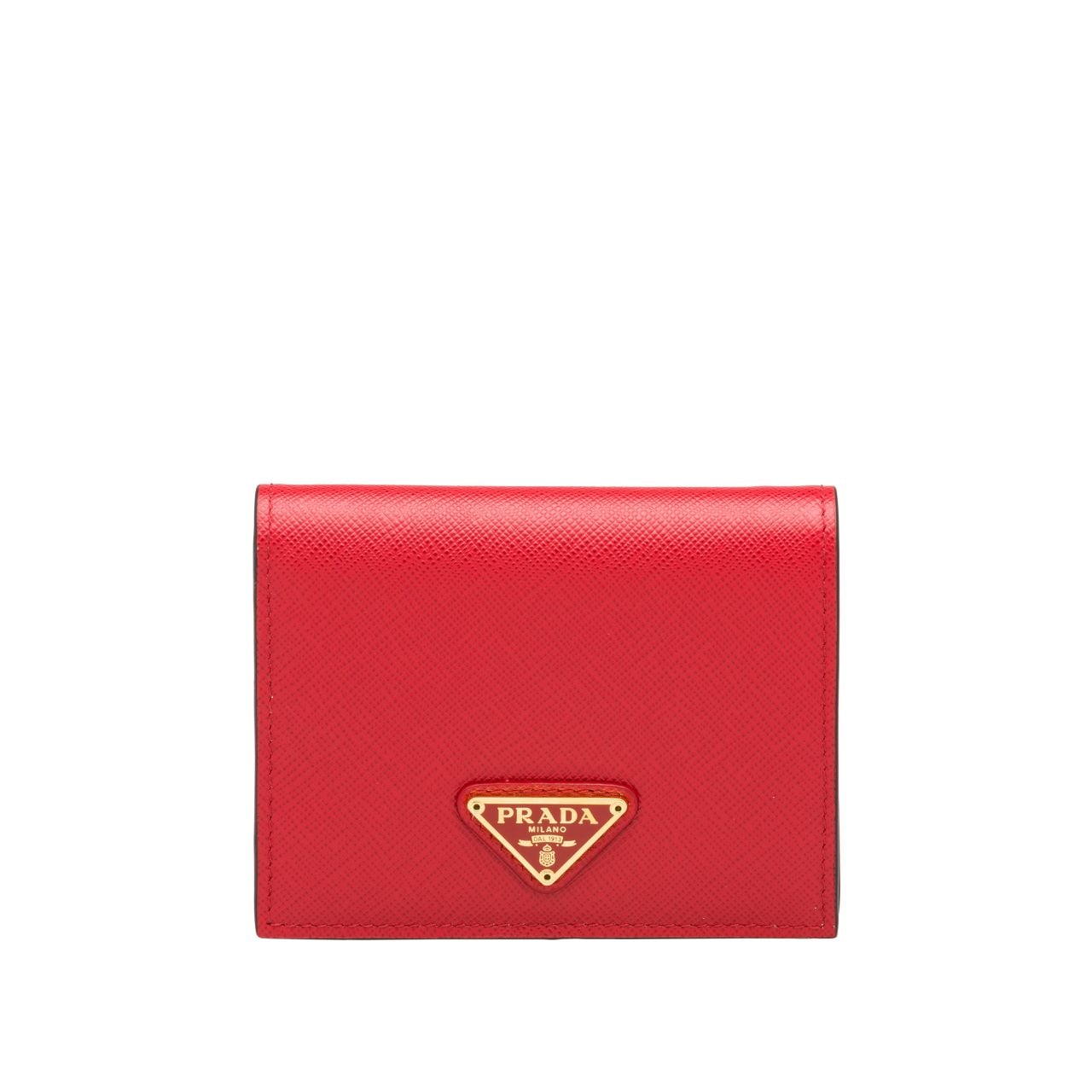

Style # 1MV204_2CDM_F0YQY

440 $

product details

Saffiano leather  
Printed interior  
Snap closure  
Three card slots  
Coin compartment  
Printed Saffiano leather and nylon lining  
Enameled metal triangle logo on the outside  
11.2 cm height  
8.5 cm width